1. **INTRODUCTION**

Nigerian National Petroleum Corporation (NNPC) was formed in 1977 through the merger of some of the departments of the Ministry of Petroleum Resources and the old Nigerian National Oil Corporation (NNOC). In 1978, the corporation was commercialized into twelve strategic business units, the Warri Refining and Petrochemical Company (WRPC) being one of them. The Warri Refining and Petrochemical Company Limited was commissioned in 1978 after the merger of the Warn Refinery and the Ekpan Petrochemical Plants by Lt. Col. Olusegun Obasanjo which was built and designed by Snamprogetti, an Italian company and with an initial capacity of 100,000 barrels per stream day of crude oil. It was de-bottlenecked in 1987 to 125,000 barrels per stream day .

**1.1 HISTORY OF WARRI REFINING AND PETRO CHEMICAL COMPANY LIMITED WRPC (A SUBSIDIARY OF NNPC)**

Nigerian National Petroleum Corporation (NNPC) was formed in 1977 through the merger of some of the departments of the Ministry of Petroleum Resources and the old Nigerian National Oil Corporation (NNOC). In 1978, the corporation was commercialized into twelve strategic business units, the Warn Refining and Petrochemical Company (WRPC) being one of them. The Warri Refining and Petrochemical Company Limited was commissioned in 1978 after the merger of the Warri Refinery and the Ekpan Petrochemical Plants by Lt. Col. Olusegun Obasanjo which was built and designed by Snamprogetti, an Italian company and with an initial capacity of 100,000 barrels per stream day of crude oil. It was de-bottlenecked in 1987 to 125,000 barrels per stream day (17,000metric tones per day). The fuel plants were designed to process the CHEVRON’S ESCRAVOS crude oil (sweet crude) and SHELL’S UGHELLI QUALITY CONTROL CENTRE (UQCC) crude oil (sour crude).

The petrochemical plants (Polypropylene and Carbon Black) which were built to optimize the refinery were commissioned in March 1988. An Hydro-Flouric Alkylation Unit was also added to the refinery the same year.

**1.2 BRIEF DESCRIPTION OF THE UNITS IN WRPC**

**Crude Distillation Unit**: This unit utilizes negative pressure to distill atmospheric bottoms into gas oils, kerosene, naphtha, residue bottoms and asphalt. The design of the unit is based on a light crude scenario and a heavy crude scenario. The unit produces raw products which have to be processed in downstream unit to produce products of certain specifications. This involves the removal of undesirable components like sulphur, nitrogen and metal compounds, and limiting the aromatic contents.

**Typical products from the unit are:**

• Gases

• Light straight run naphtha (also called light gasoline or light naphtha)

• Heavy gasoline (also heavy naphtha)

• Kerosene (also called light distillate or jet fuel)

• Middle distillates called diesel or light gas oil (LGO)

• Heavy distillates called atmospheric gas oil (AGO) or heavy gas oil (HGO)

• Crude column bottoms called atmospheric residue or topped crude

**Kerosene Hydro-treating Unit:** The purpose of this unit is to reduce the sulphur and nitrogen content of the feed and to improve combustion characteristics of transportation fuels. Catalytic Reforming Unit: This unit is used to convert naphtha boiling range molecules into higher octane reformate. Reformates has a higher content of aromatics and cyclic hydrocarbons. It also generates the hydrogen utilized in naphtha hydro treating unit to remove impurities in the reformer feed.

* **Fluid Catalytic Cracking Unit**: The basic purpose of this plant in the refinery is to convert heavy gas oil which is of less market value into lighter, more valuable hydrocarbons. As the name implies, it uses a fine powdery catalysts which under the action of fluidization medium such as air, hydrocarbon vapor or steam behaves like a liquid. The unit is designed to process 26,000bpsd of gas oil feedstock into high valued products like gasoline and LPG.
* **Hydro-Fluoric Alkylation Unit**: This is a process unit used to convert light olefins (e.g. propylene, butylenes) produced in catalytic crackers into a more highly valued gasoline component. Alkylate is one of the best gasoline blending components produced in the refinery because of its high octane rating and lower vapor pressure. It is usually referred to as a five star gasoline.
* **Waste Water Unit**: This unit is involved in both collection and treatment of sour water and sludge’s received from other units using treatment system like the API separator, dissolved air floatation, activation sludge bioreactors and some other methods to make such water suitable for re-use or disposal.
* **Polypropylene Plant**: Polypropylene is a thermoplastic polymer obtained by linking together many molecules of propylene (-CH2CH2CH2-) a monomer. The monomer is collected in pressure vessels purified and polymerized to produce a homo-polymer. A blend on ethylene could be added in a secondary reactor to obtain a co-polymer which has enhanced properties. The PP plant in WRPC is designed to produce 35,000 MT per year of Polypropylene pellets.
* **Carbon Black Plant**: This plant is designed to produce 18,000 MTPA and is capable of producing several grades of hard black. Carbon black is used in the manufacture of inks, paints, conveyor belts, foot wears, and other commodities.

**THE MARKETABLE PRODUCT ARE :**

1. premium motors spirit (PMS) (petrol)
2. kerosene (Domestic/Aviation)
3. Automotive gas oil (AGO) (Diesel oil)
4. Fuel Oil
5. Liquefied petroleum Gas (LPG) (Cooking Gas)
6. Polypropylene pellets (Nipolene)
7. Carbon black pellets

**PRODUCTS AT MAXIMUM DESIGN CAPACITY**

**PRODUCTS METRIC TON/DAY LITRES**

TOTAL PMS 50,015 6,598,684

KEROSENE 2,380 2,902,439

AGO 4,522 5,258,139

TOTAL FUEL OIL 3,808 4,094,623

BUTANE 459 791,379

PROPANE 187 366,666

**1.3 HEALTH, SAFETY AND ENVIROMENT (HSE)**

Since the company is in a business to optimally process hydrocarbon, its success is built around quality,teamwork and professional geared toward commitment to performing job safety .it is important to note that safety is each employee’s responsibility and performing each task safety makes everyone’s job easier in the long run.

HSE incident include fatality (death of people), and damageto critical equipment due to violation of safety rules job procedures, bad unsafe behavior such as talking shortcuts underlined by inadequacy for work tasks and increase in activities.

**1.4 HSE TERMS**

**Goal zero**; this means relentlessly pursuing no harm to no people and no significant incidents.

**Hazard**- this is anything that has potential to cause accident.

**risk ;** is the inherent characteristic of material, condition, or activity that the potential to cause harm to people, property , or environment.

**Threat ;a** possible cause that will release a hazards to produce a top event. Thus this threat is that which release a hazard.

**Barrier;** a measure put in place to prevent threat from releasing a hazard.

Examples are warnings, training, rules, safety valves, lower speed, etc.

**Consequence;** an event or chain of events that result from the release of a hazard.

E.g. injury, illness, damage to equipment, etc.

Hence, the HSE goal is constantly encourage and maintain good HSE performance in collective effort toward ensuring no more injury to people, damage to the environment and damage to assets.

Safety principles

(1) Hazard control

(2) Engineering method

(3) Elimination method

(4) Administrative method.

Personal protective equipment (PPE)

Face protective equipment, safety boots, helmet, hand gloves, eye goggle

* **FIRE SECTION**

Fire is a chemical reaction between three elements fuel, heat and oxygen. It has also been described as exothermic reaction involving combustion. These three elements must be in the right proportion.

Tradition fire triangle: - they are oxygen-heat-man. The two major factor of initiate fire are (1) man (2) natural phenomenon.

**Type of fuel**: - (a) solid fuel e.g. wood, paper, petroleum wax, combustible metals. Etc. (b) liquefied e.g. crude oil, kerosene. Petrol, diesel oil. Etc. (c) flammable gas e.g. natural gas,LPG, hydrogen gas.

* 1. **FIRE STAGES**

**Incipient stage**: - this is the region where preheating just started. It is still controllable at this stage.

* **Smoldering stage**:-this is the region of fully developed pyrolsis that begins with ignition and includes the initial stage of combustion. Invisible and visible small particles are generated and transported. At this stage water mix with detergent or fire extinguisher can stop this fire.

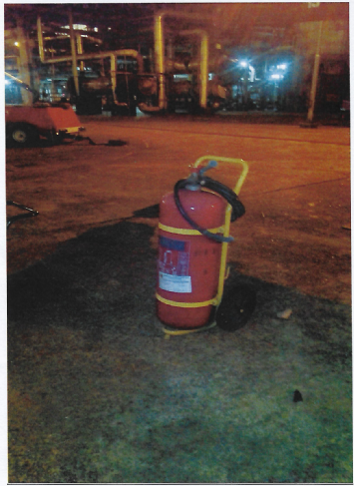

Fig 2.1 fire extinguisher (use in fighting fire)

* **Flaming stage**: - this is the region of rapid reaction that covers the period of initials occurrence of flow of fully developed. At this stage this assistance of fire fighting bodies should be call upon.

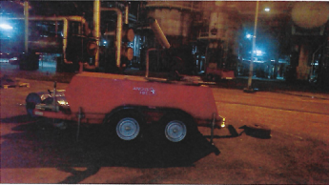

Fig 2.2 Angus fire. (Used in fighting fire) mobile foam unit

Augus Hi-combat AF 120 is fully self contained mobile foam unit which has been specifically developed for the rapid deployment of foam extinguishing agent to fires and chemical spills. Required only connection to a suitable water supply, also two 15m length of dutch coiled 45mm diameter duraline fire hose, fitted with light alloy 21/2’’ instantaneous coupling to BS336 ( other connection available to special order). A shut off ball valve is also fitted to the inductor as standard, to facilities swift operation by one person

**1.7 BODY MECHANIC AND TOOLS**

Poor body mechanic when handling an object or using tools can result in injury.

The following precaution must be taken;

1. Do not carry out work if you do not have the right tools for the job and the environment.
2. Two people or machinery may be needed to perform work, depending on the weight, size or bulk of the load.
3. Adapt your body mechanics to the tool rating and repetitive motions.
4. Follow the appropriate operating procedure for the tools.

**1.8 PERSONAL PROTECTIVE EQUIPMENT**

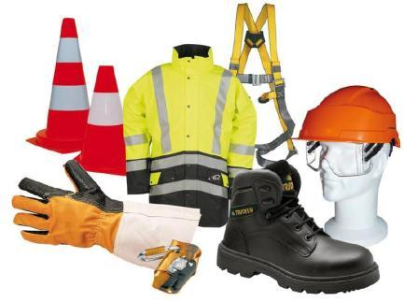

Fig 2.3 (PPE)

Collective protective equipment must be installed and maintain in good condition. It includes protective devices on dangerous machinery, gratings, safety rails, elevator and freight elevator safety devices, etc.

In installations, wear general personal protective equipment (PPE), such as;

Coveralls

* Safety shoes
* Safety glasses
* Safety gloves
* A hard hat with whose useful life can be verified
* Hearing protection in specified areas

They are some rules you must abide to in the processing area, which include;

* Do not access installation or perform work without wearing general or task-specific PPE
* The rules concerning PPE must be clearly defined and disseminated
* Collective protective equipment must be in good condition, especially protective devices for machinery, gratings, and safety rails.
* Carefully inspect personal protective equipment (PPE)

**CONFINE SPACE;**

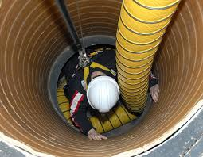

You may only enter a confine space, such as a tank, pit or vessel, etc. these are some of the safety rules you must abide to:

* Do not enter a confine space until isolation has been verified and the atmosphere is checked.
* A safety attendant must be nearby to monitor the workers.
* Suffocation, falls, explosion, crushing, drowning, and other risks must be addressed.
* An emergency evacuation plan must be prepared.

WORK ON POWER SYSTEM

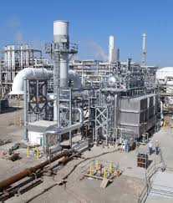

Some work can only be confirmed after lockout of the production or the energy (mechanical, electrical, hydraulic, thermal and radioactive).

Some work can only be performed if

* An appropriate work pe rmit is prepared and approved, complete with all the associated attachment.
* The equipment operator and the person check physical isolation.
* A lockout-tagout system is used.
* The isolation and its effectiveness are regularly checked.
* The operator is present whenever a product system representing a risk for the people performing the work is opened.

**REFERENCES**

Coulson J.M. and Richardson J.F. (2002): Particle Technology and Separation Processes of Chemical Engineering.

Warri Refining and Petrochemical Company Limited, safety management Operational

Manual.